**How to integrate IBO Digital Barcode Generator in RDLC report**

This document will provide an overview of how to generate Barcodes using “IBO Digital Barcode Generator” extension.

1. Install IBO Digital’s Barcode Generator extension from Microsoft AppSource.
2. Prerequisite for developer is that you need to know how to configure app.json & launch.json

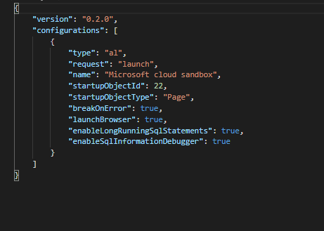

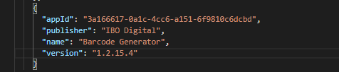

Note: You might need to change version in app.json as per the recent installed version

1. Once all basic configuration is done & downloaded the latest symbols, delete the ‘HelloWorld.al’ file & create a report file shown below.

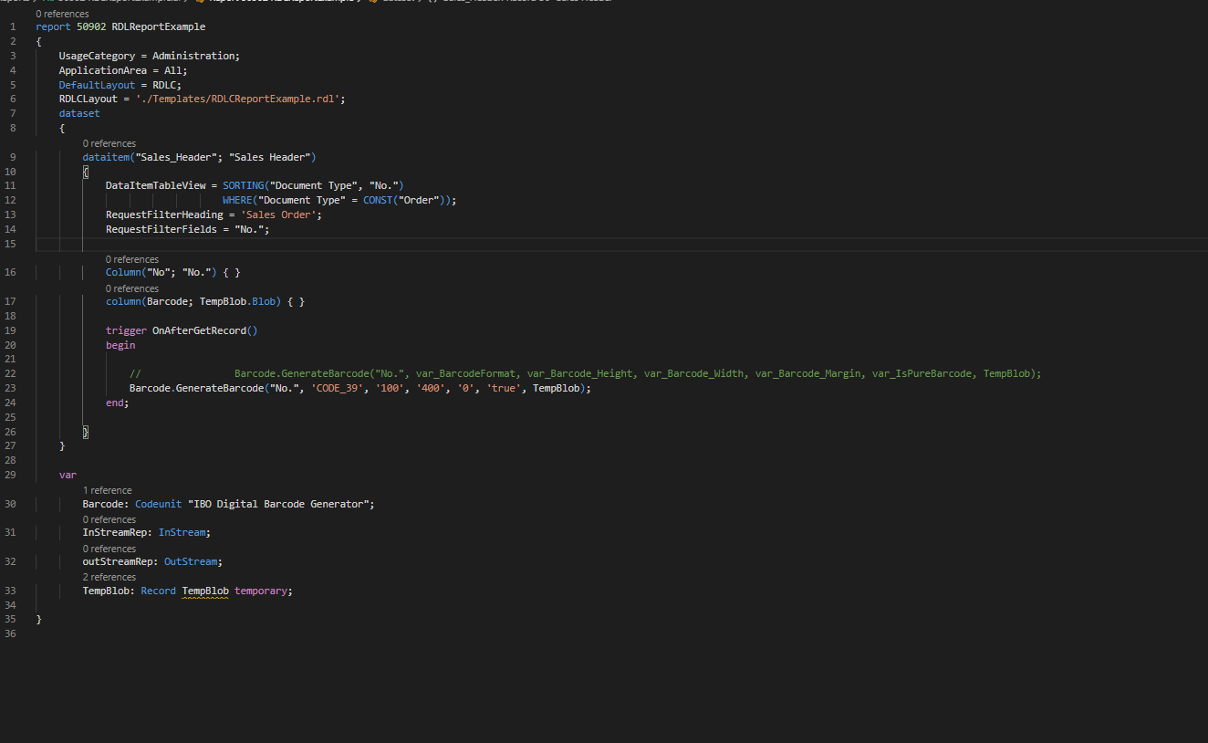

1. Publish the report using by going to command pallet View🡪Command Pallet
2. Once the report is published, it will automatically generate RDLCReportExample.rdl under Templates folder

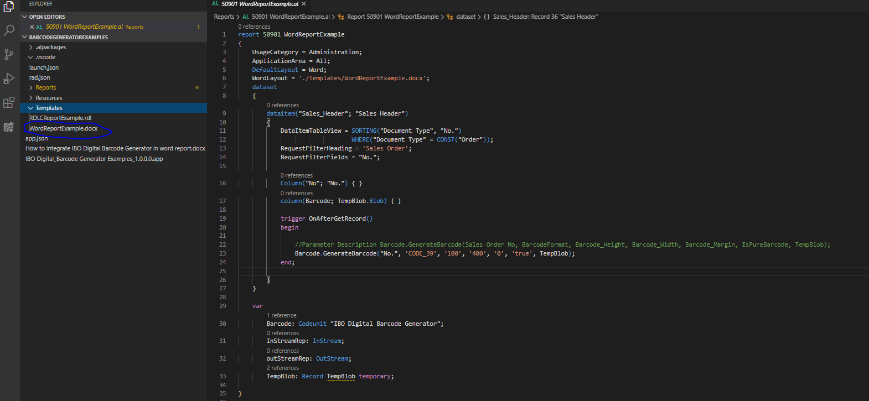

1. Open a RDLCReportExample.rdl file in externally in Report Builder

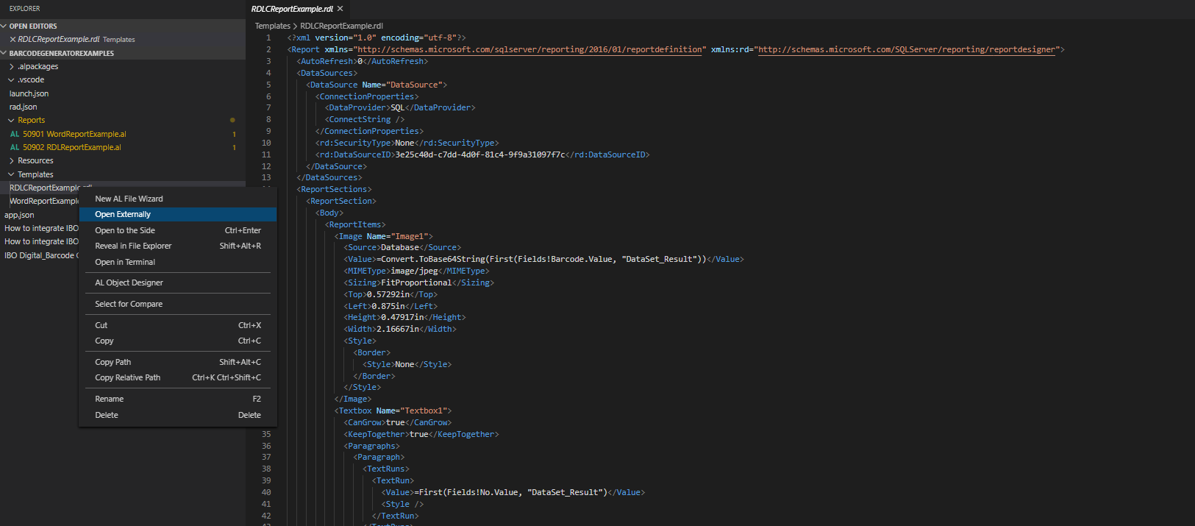

1. Click on “Image” from the menu to Insert Image field.

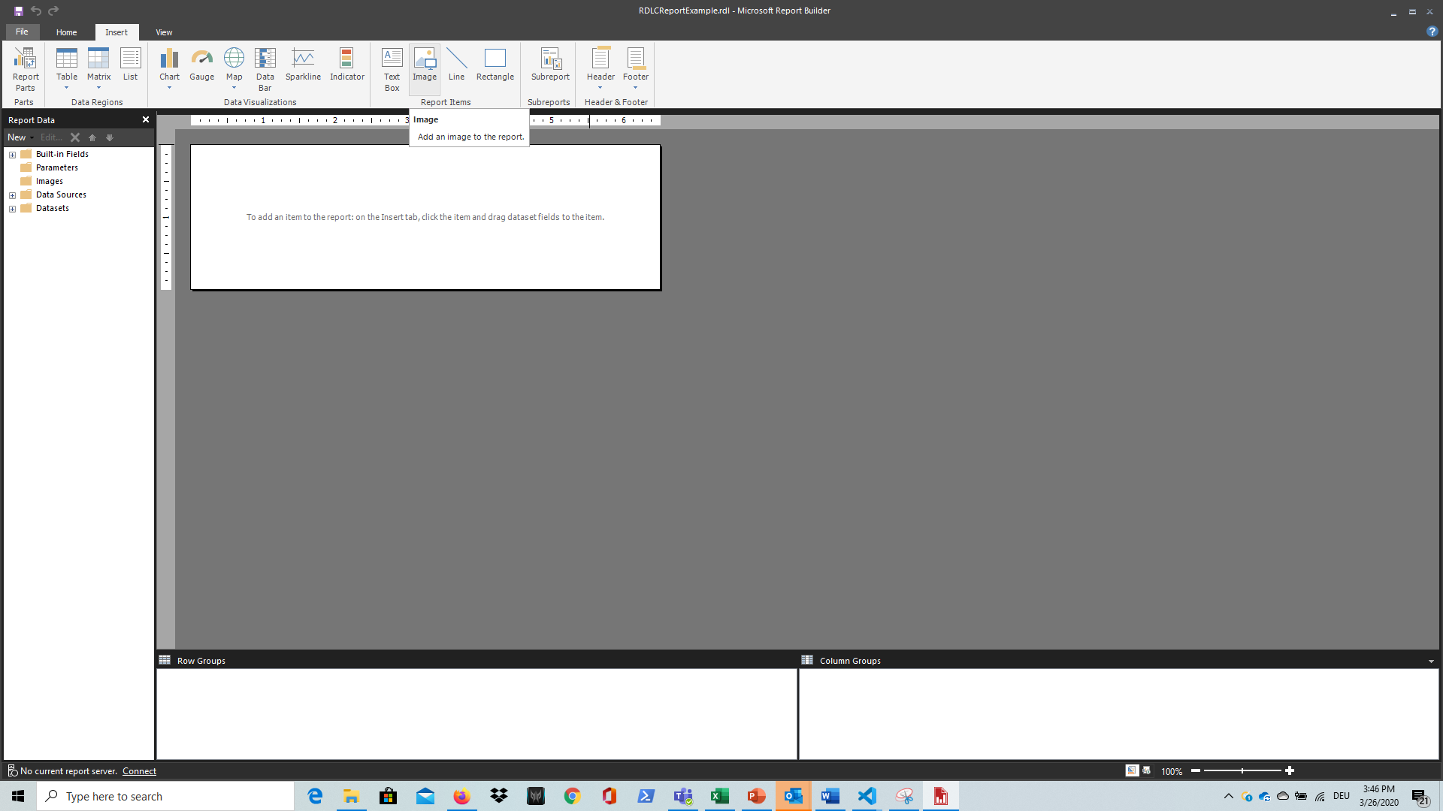

1. In the Image property set change the image source as “Database”

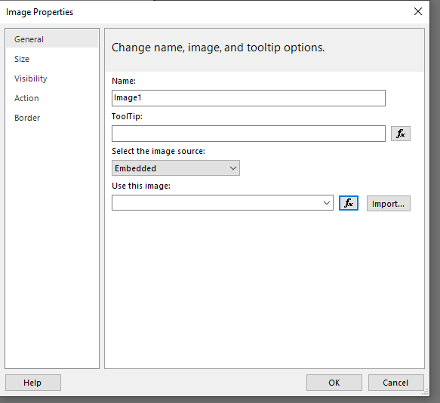

1. Set the MIME type as “image/jpeg”

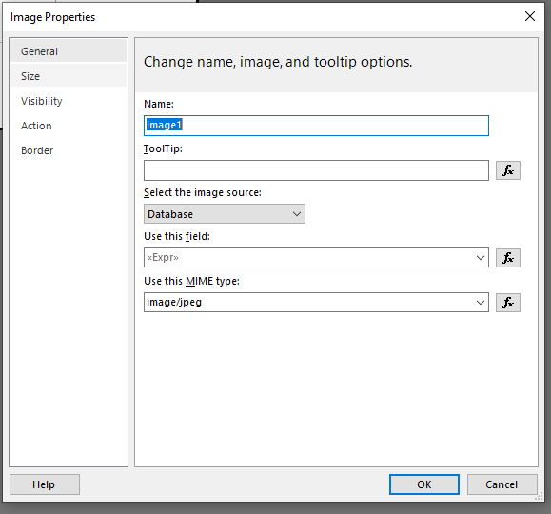

1. In the expression add following formula and click on OK.

=Convert.ToBase64String(First(Fields!Barcode.Value, "DataSet_Result"))

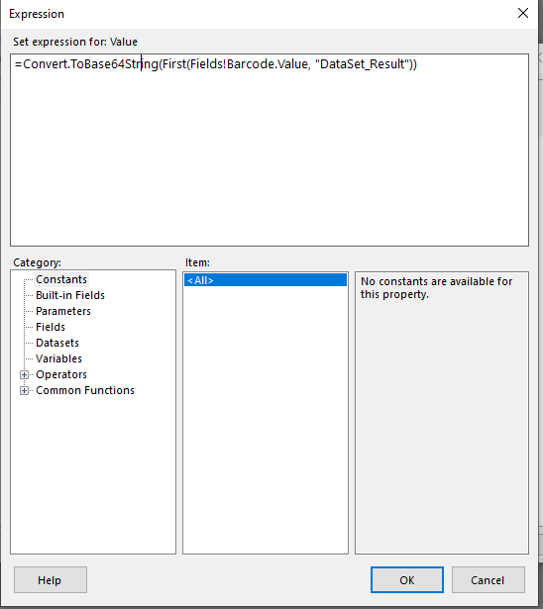

1. Save & close the report.
2. Publish extension in Business Central
3. To test the report Open Business central Web client & create new “Custom Report Layout”

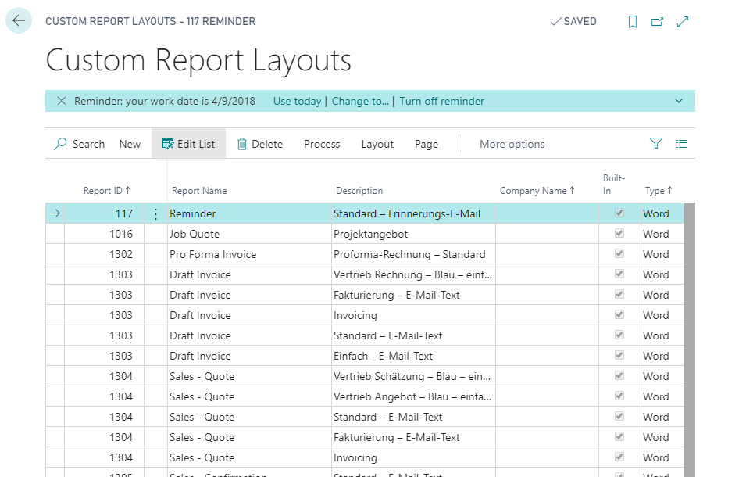

1. Select our published report by entering report id

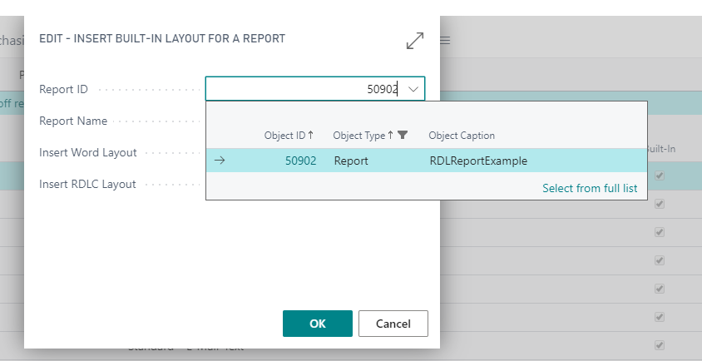

1. Select Insert Word layout option

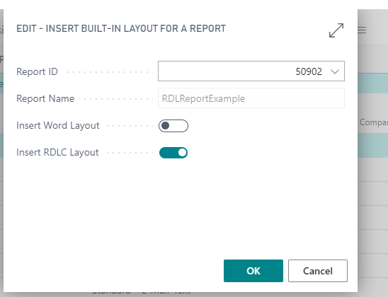

16.Import our updated RDL template

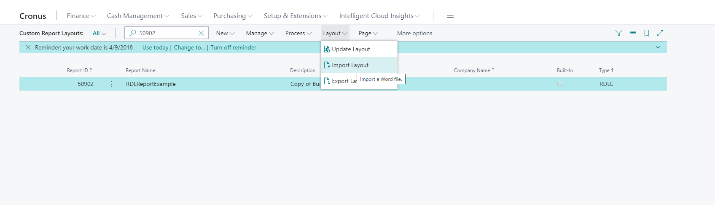

1. Run the report

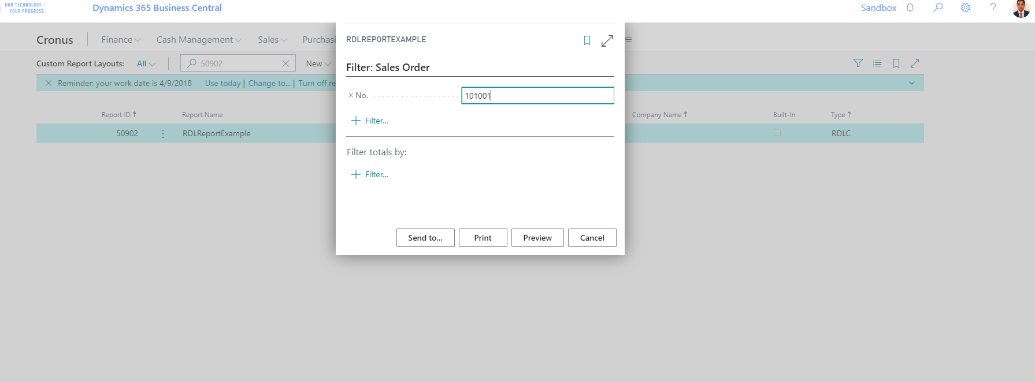

1. Click on “Preview” button

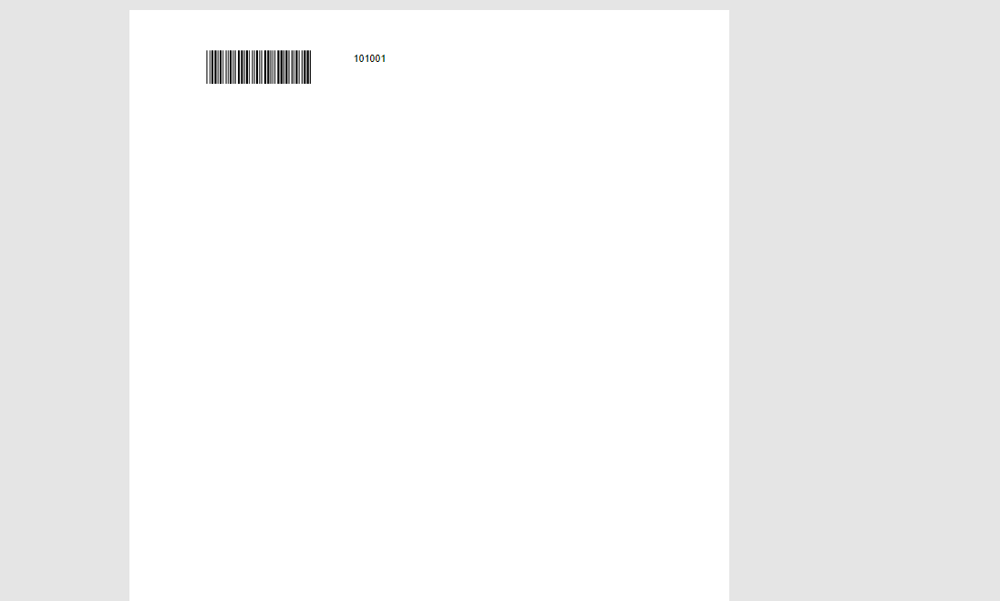

If you have any questions about Barcode Generator or Business Central questions for any version, Contact us on [**IBO Digital**](https://www.ibodigital.com/contact/)